**Exploring Convections Currents – Lab (Procedure and Background)**

**Objective: To construct several models to demonstrate the principle of the convection, and to use your observations to  explore the role convection plays in the development of atmospheric circulation and ocean currents.**

**Materials Needed per Lab Group  
1 clear Plastic Box  
1 Beaker: 50 ml  
1 pipette  
6 Styrofoam Cups**

**Food Coloring   
Water ( Hot and cold)  
Ice Cubes  
Colored Pencils**

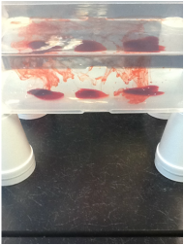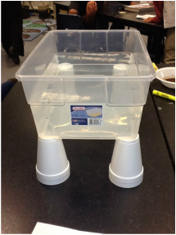**Set-up A  
1. Take 4 Styrofoam cups and turn them upside down. Set the clear plastic box onto the four Styrofoam cups as shown in the figure. Carefully fill the box with cold tap water to within 3-4 cm from the top. Let the water calm before proceeding.**

**2. Using the pipette, carefully place 3 spots of red food coloring on the bottom of the box as shown in figure 2. Insert the pipette all the way down to the bottom of the box before squeezing out the dye. Each spot should be about 2-4 cm in diameter. Try to minimize disturbing the water as you insert and remove  the pipette.**

**3. Fill one empty Styrofoam cup with hot water and then carefully position it beneath the center dye spot.**

**4. Now position yourself so that you can view the box from the side at eye level, and observe what happens to the 3 spots over the next 5 minutes. Be sure to look for changes in all 3 spots. Write your observations below.**

**5. Describe and draw what you observed on your data sheet under set-up A**

**6. Using two hands under the box, carefully, empty the water into a sink and begin Setup B**

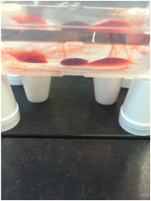**Setup B  
1. Repeat procedures 1 & 2 from Setup A to set up the box one again.   
2. This time, fill two cups with hot water and position them beneath the two outside spots. Observe what happens over the next 10 minutes, and then sketch and describe what you observed on your data sheet under set up B. Be sure to look for changes in the middle spot. Use arrows to show direction of flow.   
 3. Carefully empty the water from the box into a sink, and begin Setup C.**

**Setup C   
1. Set up the plastic box once again as in Setups A & B and fill with cold tap water to within 3-4 cm of the   
top. Let the water become calm. Next, place two spots of food coloring near one end of the box. Position   
one cup of hot water beneath each spot.   
2. Use a plastic spoon to obtain a blue ice cube from your instructor. Carefully set the cube into the water   
at the opposite end of the box from your dye spots. Use the spoon to steady the cube until it stops   
moving.   
3. Position yourself at eye level with the side of the box, and observe the water as the ice cube melts.   
Sketch your observations on your data sheet under “Set-up C”. Use arrows, once again, to indicate flow direction.**

